**QUAID-I-AZAM UNIVERSITY OF ISLAMABAD**

**SOFTWARE CONSTRUCTION**



**Green Zone Connect**

**GROUP VI – BSCS 5TH SEMESTER**

|  |  |
| --- | --- |
| **SYED SHEERAZ ALI SHAH** | **04072212001** |
| **AWAIS ALI** | **04072212045** |
| **KHURRAM SHAHZAD** | **04072212029** |

**SUBMITTED TO : MAM ONAIZA MAQBOOL**

**SUBMISSION DATE: 11th MARCH 2024**

**Project Plan Approval Signatures**

**Customer Approval Signature**

I, **Dr. Onaiza Maqbool**, as the project stakeholder, acknowledge that the **Green Zone Connect** meets the acceptance criteria outlined in the Acceptance Plan. Upon sign-off, the platform will be considered ready for deployment and usage by the target audience.

**Signature:______________________**

**Name: Onaiza Maqbool**

**CNIC: xxxxx-xxxxxxx-x**

**Contact No: 0000-0000000**

**Project Team Approval Signature**

We as the project Team, acknowledge that the **Green Zone Connect** meets the acceptance criteria outlined in the Acceptance Plan. Upon sign-off, the platform will be considered ready for deployment and usage by the target audience.

**Signature:______________________ Signature:______________________**

**Name: Syed Sheeraz Ali Shah Name: Awais Ali  
(Team Leader) CNIC: xxxxx-xxxxxxx-x**

**CNIC: xxxxx-xxxxxxx-x Contact No: 0000-0000000**

**Contact No: 0000-0000000**

**Signature:______________________**

**Name: Khurram Shahzad**

**CNIC: xxxxx-xxxxxxx-x**

**Contact No: 0000-0000000 Date:_________________________**

**Revision History**

|  |  |  |  |
| --- | --- | --- | --- |
| **Version No** | **Date** | **Modified by** | **Significant Changes** |
|  |  |  |  |
|  |  |  |  |
|  |  |  |  |
|  |  |  |  |
|  |  |  |  |
|  |  |  |  |
|  |  |  |  |
|  |  |  |  |
|  |  |  |  |
|  |  |  |  |
|  |  |  |  |

**Remarks**

___________________________________________________________________________

___________________________________________________________________________

___________________________________________________________________________

___________________________________________________________________________

___________________________________________________________________________

___________________________________________________________________________

___________________________________________________________________________

___________________________________________________________________________

___________________________________________________________________________

**Signature:______________________**

**Name: Onaiza Maqbool**

**CNIC: xxxxx-xxxxxxx-x**

**Contact No: 0000-0000000**

**Preface**

As students of Quaid-I-Azam University Islamabad, pursuing BSCS degree, we have been assigned to develop software named GreenZone Connect which aims to organize and facilitate various environmental activities. We, Syed Sheeraz Ali Shah (Project Manager), Khurram Shahzad and Awais Ali (Project Team) under the guidance of our esteemed course instructor Dr. Onaiza Maqbool embark on a journey of innovation and collaboration.

We express our sincere gratitude towards our advisor Dr. Onaiza Maqbool for entrusting us, who will further be guiding us throughout the project.

By the end of this semester, we are committed to developing a robust and user-friendly platform highlighting our collective skills, imagination, and our ability to achieve our goals.

Table of Contents

Chapter 1 Software Project Management Plan 6

1.1 Project Overview 9

1.1.1 Project summary 9

1.1.2 Purpose 9

1.1.3 Scope 9

1.1.3.1 Functionality 9

1.1.4 Objectives 9

1.1.5 Assumptions and Constraints 10

1.1.6 Project Deliverables: 10

1.1.7 Schedule Summary: 10

1.2 References: 10

1.3 Definitions: 10

1.4 Project Context: 10

1.4.1 Process Model: 11

Model: 11

1.4.2 Methods, Tools, and Techniques 12

1.4.3 Product Acceptance Plan 12

1.5 Project Planning 15

1.5.1 Project Work Plans 15

1.5.1.1 Work Activity 15

1.5.1.2 Schedule Allocation 17

1.5.1.3 Resource Allocation 18

1.8 Supporting Process Plans 18

1.8.1 Risk Management 18

Use Case Diagram 20

Use Case Descriptions 21

UC-1 Define Area 21

## Chapter 1 Software Project Management Plan

Index of Tables

Table 1: Method Tools and Techniques 12

Table 2: Project Work Plan 16

Table 3: Risk Management 19

Table 4: Define Area UC-1 By Sheeraz Ali Shah 21

Table of Figures

Figure 1: Water Fall Process Model with feedback 11

Figure 2: Gantt Chart 17

Figure 3: Resource Allocation Table 18

Figure 4: Use Case Diagram 20

## 1.1 Project Overview

### 1.1.1 Project summary

This project builds a platform for organizing environmental activities such as tree plantations and cleanups. The software will allow areas/neighborhoods to be defined. People can then join a certain neighborhood allowing groups to be formed. These groups will be able to organize several types of activities in a neighborhood, e.g., cleanup, tree plantations etc. Each activity may have different items of interest which a user may define. For example, in the case of a tree plantation, type of tree, date of plantation, total trees in an area may be noted. When the activities are scheduled, alerts will be sent to each member. After an activity, photos and videos related to the activity may be uploaded. Groups/Areas can be ranked based on number of activities of various kinds.

### 1.1.2 Purpose

The purpose of this project is to empower individuals to take part in such activities and to keep the environment neat and clean as it plays a significant role in healthy living and the existence of life on planet Earth. It also promotes community engagement. Uploading photos/videos related to each activity focuses on creating awareness among people regarding environmental activities and their importance. Ranking the groups/areas based on its performance is essential to track progress and to check which area still needs to be worked on.

### 1.1.3 Scope

Green Zone connect is a software application being developed to facilitate the organization of environmental activities within a community by providing a centralized hub for coordination, collaboration, and resource-sharing.

#### 1.1.3.1 Functionality

Its intended use includes:

* Allow user to form distinct groups
* Schedule an activity
* Update an activity
* Delete an activity
* Send alerts
* Maintain activity documentation i.e., photos and videos may be uploaded
* Track progress of a particular area/group

### 1.1.4 Objectives

* To maintain a pleasant environment around people
* To save and protect our environment
* To promote environmental awareness
* To reduce pollution
* To help preserve earth’s natural resources
* To facilitate community engagement

### 1.1.5 Assumptions and Constraints

1. Assuming that every individual is willing to participate in various activities
2. Assuming accurate data is being entered
3. Mobile device must be available
4. Internet access must be available
5. Platform functionality depends upon accuracy of data
6. A geo location service must be available

### 1.1.6 Project Deliverables:

* 1. Software Project Management Plan (SPMS)
  2. Software Requirements Specification (SRS)
  3. Software Design Description (SDD)
  4. Software Test Documentation (STD)

### 1.1.7 Schedule Summary:

This project aims to be completed by the end of this semester (16 weeks (about 3 and a half months) approx.).

Planning Phase: 2nd Week

Analysis Phase: 3rd – 5th Week

Design Phase: 6th – 9th Week

Development Phase: 10th – 13th Week

Testing Phase: 14th – 16th Week

## 1.2 References:

1. ISO/IEC/IEEE 16326:2019(E) 2nd edition

2. ProjectLibre Manual Version 0.1 - Oct 6, 22

## 1.3 Definitions:

ISO: The International Organization for Standardization

IEC: International Electro-technical Commission

IEEE: The Institute of Electrical and Electronics Engineers

### 1.4 Project Context:

### 1.4.1 Process Model:

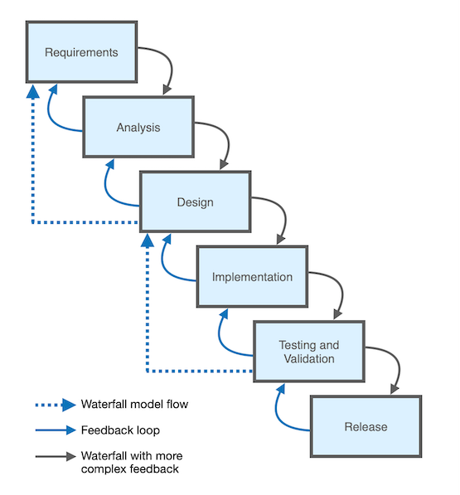Figure 1: Water Fall Process Model with feedback

### Model:

GreenZone Comfort software is based on the Waterfall model with feedback system.

**Reasons:**

* Defined requirements.
* Emphasizes continuous feedback loops between development teams and stakeholders.
* Incremental delivery of the project.
* Risk management will be efficient due to the iterative refinements in the project.
* Clear roles and responsibilities within the team.

### 1.4.2 Methods, Tools, and Techniques

|  |  |
| --- | --- |
| **Tool** | **Purpose** |
| **Project Libre** | Used for creating timeline, planning and Gantt chart of project. |
| **Argo UML** | UML diagram tool for making diagrams |
| **VS code** | Code editor used for development of project |
| **Language** | Java, HTML, CSS, PHP |
| **Office Libre** | Used for Creating Documents (Project Plan, SRS etc.) |
| **Method** | Object oriented programming (OOP) |
| **MS Power Point** | Used for Creating Presentation . |
| **Wamp Server** | Wamp: “Windows, Apache, MySQL and PHP”  Server: Computer program that provides services to other applications or clients. |
| **Azure DevOps** | Provides a complete set of tools to manage software development projects. |

Table 1: Method Tools and Techniques

### 1.4.3 Product Acceptance Plan

**1. Functional Requirements Testing:**

* Check that users can register accounts, create profiles, and join neighborhoods by deploying the software for demo before release.
* Check that users can form groups within neighborhoods without adding outsiders to their groups and organize various activities.
* Test the functionality of viewing, deleting, updating and creating new groups.
* Check the alerts should be sent on proper time on scheduled time.
* Check that users can upload photos and videos related to activities done.

**2. Usability Testing:**

Conduct the test of usability by certain users to ensure the system is easy to use or not.

Gather feedback from user so you can find problem related to usability of software.

Address usability issues during testing to improve user satisfaction.

**3. Performance Testing:**

Check response times for various actions such as registering accounts, joining groups, updating groups, viewing groups, deleting groups, sending alerts and uploading multimedia.

Finding and fixing problems that slow down a system or unable to handle more work is Important so over software can run smoothly.

**4. Security and Privacy Testing:**

Ensure that unauthorized person cannot access the data of user.

Ensure that user data is stored securely and no one can attack on the data and access the sensitive information of the user.

**5. Maintainability Testing:**

Ensure that the software would be easy to maintain and update.

**Test maintainability by updating various features.**

**6. Acceptance Criteria:**

User Registration and Authentication:

User should be able to create an account.

User can login to the system.

In case if user forgets the password there must be a way to reset the password.

Define Areas/Neighborhoods:

User should be able to define areas by name, area coordinates and other parameters.

**Groups:**

User should be able to create , Join groups ,leave groups and view groups.

**Activity Participants Presence:**

There must be a mechanism for the admin of the group to mark the attendance of volunteers against each activity.

**Organizing and Scheduling Activities:**

The group admin should be able to organize and schedule activities and user should be able to view scheduled activity in the groups.

Alerts and Notifications:

After scheduling an event the group member should get notification alert on their device.

Uploading Photos and Videos:

After each activity, the team leader might want to add photo and video in order to improve the group profile. So Any one in the group should be able to upload photo and videos of the event

Ranking of Groups/Areas:

**The application should be capable of ranking areas and groups.**

**8. Documentation and Training:**

In this stage we will create a short documentation for user so he can use it. Diagrams will be used in this document so user can use the product easily.

**9. Final Review and Approval:**

The Final Approval will be given by the project stake holder after the stake holder has read the acceptance criteria. Upon sign-off, the platform will be considered ready for deployment and usage by the target audience.

## 1.5 Project Planning

## 1.5.1 Project Work Plans

## 1.5.1.1 Work Activity

|  |  |  |  |  |  |  |
| --- | --- | --- | --- | --- | --- | --- |
| **ID** | **Work Activity** | **Resources** | **Estimated Duration** | **Work Product** | **Acceptance Criteria** | **Predecessor** |
| 1 | Define Project Scope | Project Manager, Stakeholder | 1 day | Scope Statement | Stakeholder satisfied | None |
| 2 | Develop Project Plan | Project Manager, Project Team | 4 days | Project Plan | Match the actual 16-week schedule | Define Project Scope |
| 3 | Defining Use Cases | Project Manager, Project Team | 7 days | Use cases | Case Study criteria fulfilled; Stakeholder satisfied | Develop Project Plan |
| 4 | Developing Analysis Models | Project Manager, Project Team | 7 days | Analysis Models | Covers all major analysis models | Defining Use Cases |
| 5 | Developing SRS | Project Manager, Project Team | 7 days | SRS document | Models map onto each other; Stakeholder satisfied | Developing Analysis Models |
| 6 | Design principle, Data design | Project Manager, Project Team | 7 days |  | Data defined clear fully | Developing SRS |
| 7 | Interface Design | Project Manager, Project Team | 7 days | Interface | Good design; Stakeholder satisfied | Design principle, Data design |
| 8 | Detailed Designing | Project Manager, Project Team | 7 days |  | Error prone free and robust | Interface Design |
| 9 | Refining Design | Project Manager, Project Team | 7 days |  | Stakeholder satisfied | Detailed Designing |
| 10 | Database Connectivity | Project Manager, Project Team | 7 days |  | Data stores at the right place | Refining Design |
| 11 | Refining Front-end | Project Manager, Project Team | 7 days | Front-end | Stakeholder satisfied | Database Connectivity |
| 12 | Developing Classes | Project Manager, Project Team | 7 days | Defined Classes | Developed according to project scope, majority (negotiable) requirements fulfilled | Refining Front-end |
| 13 | Refining Classes | Project Manager, Project Team | 7 days |  | Stakeholder satisfied | Developing Classes |
| 14 | Testing Software | Project Manager, Project Team | 7 days |  | No error occurs; robust | Refining Classes |
| 15 | Making PowerPoint Presentation | Project Manager, Project Team | 3 days | PowerPoint Presentation | Covers forecast, outline, motivation, problem statement, methods, results, summary, future work, all major diagrams; Project Manager satisfied | Testing Software |

Table 2: Project Work Plan

### 1.5.1.2 Schedule Allocation

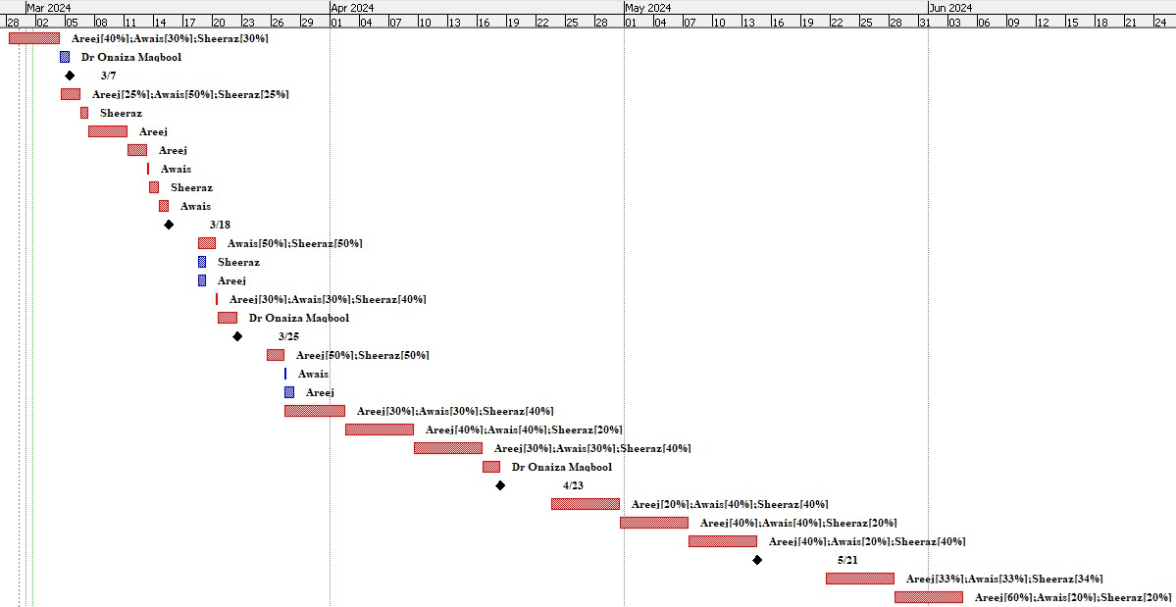Figure 2: Gantt Chart

#### 1.5.1.3 Resource Allocation

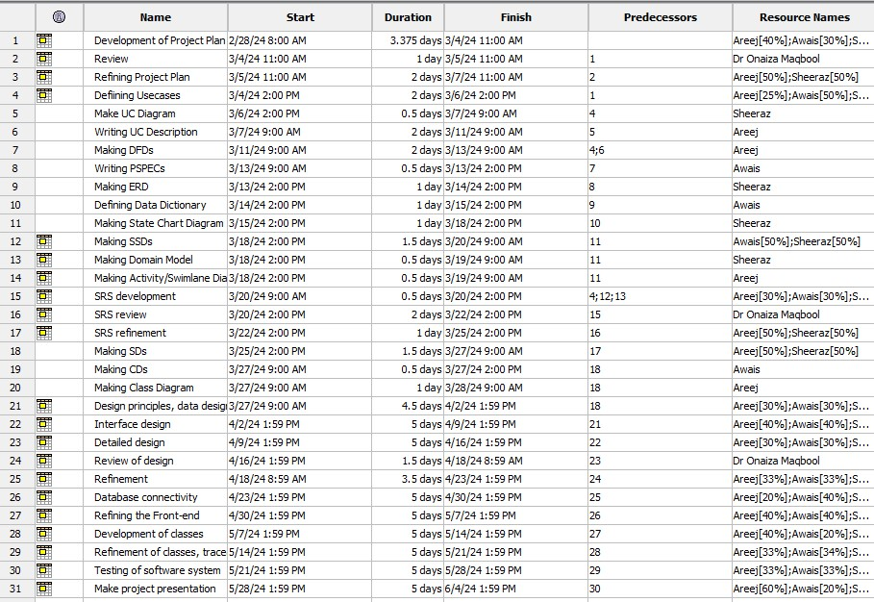Figure 3: Resource Allocation Table

## 1.8 Supporting Process Plans

### 1.8.1 Risk Management

|  |  |  |  |  |  |
| --- | --- | --- | --- | --- | --- |
| **ID** | **Risk** | **Category** | **Probability** | **Impact** | **RMMM** |
| **1** | Natural disasters | External | 5% | 5 | Establish contingency plans and emergency protocols. |
| **2** | Limited availability of resources | Internal | 60% | 4 | Prioritize tasks, optimize resource allocation, consider outsourcing if necessary. |
| **3** | Communication breakdowns in team | Internal | 70% | 5 | Foster open communication channels, hold regular team meetings, use collaboration tools. |
| **4** | Lack of stakeholder involvement | External | 50% | 3 | Engage stakeholders early, provide regular updates, and solicit feedback actively. |
| **5** | Security vulnerabilities | Technical | 40% | 2 | Implement robust security measures, conduct regular security audits and updates. |
| **6** | Lack of integration expertise | Technical | 35% | 4 | Invest in training, hiring, or consulting with experts, leverage integration tools and frameworks. |
| **7** | Inefficient testing | Process-related | 30% | 3 | Develop comprehensive test plans, automate testing processes where possible, and allocate sufficient time and resources for testing. |

Table 3: Risk Management

## Use Case Diagram

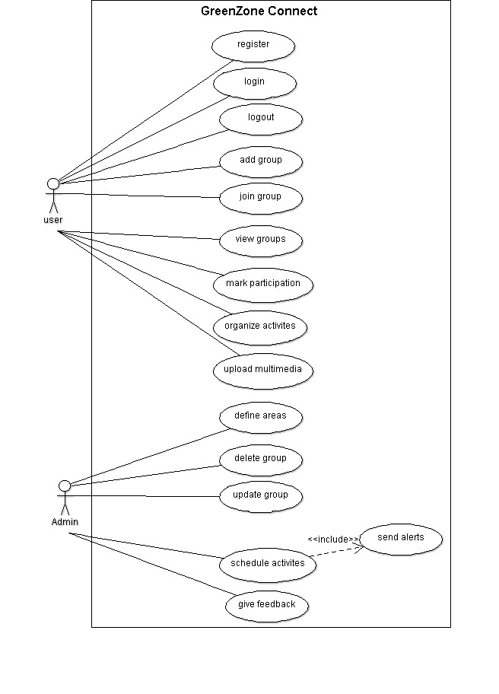Figure 4: Use Case Diagram

## Use Case Descriptions

### UC-1 Define Area

The system provides the facility to define the area so that this data can be used to create groups.

|  |  |
| --- | --- |
| **USE CASE ID** | UC-1 |
| **USE CASE NAME** | Define area |
| **PRIMARY ACTOR** | Admin |
| **STAKE HOLDER AND INTEREST** | Admin: Interested in defining the area where event may take place. |
| **PRECONDITION** | Admin is logged in to the system |
| **POST CONDITION** | The area will be saved in the system |
| **MAIN SUCCESS SCENARIO**  **(BASIC FLOW)** | 1. Admin select the option to define area. 2. The system will display the form to enter the area details. 3. Admin fill area details. 4. Admin submits the area information to the system. 5. The system informs the admin whether the area information was stored successfully. |
| **ALTERNATE FLOW**  **(EXTENSION)** | A: Mandatory Field not filled:  If the admin leaves the mandatory fields empty then the process will be as follows:   1. The system displays a message “Mandatory Field is missing”. |
| **SPECIAL REQUIREMENT TECHNOLOGY** | None. |
| **FREQUENCY OF USE** | High |
| **SPECIAL ISSUES** | None. |

Table 4: Define Area UC-1 By Sheeraz Ali Shah